**Synthesis, DFT Studies, and Biological evaluation of new thiadiazole derivatives as anti-proliferative agents**

Parin Sidat1,2, Malleshappa Noolvi*1, Jpan G. Brahmbhatt3, Sanket Rathod4, Rahul Patil5, Rakesh M. Rawal3,Prafulla Choudhari4

1PhD Scholar, Pharmacy branch, Gujarat Technological University, Ahmedabad, Gujarat, India

2Department of Pharmaceutical Chemistry, Shree Dhanvantary Pharmacy College, Kim-394110, Gujarat, India.

3Department of Life Science, School of Sciences, Gujarat University, Ahmedabad-380 009, Gujarat, India

4Department of Pharmaceutical Chemistry, Bharati Vidyapeeth College of Pharmacy, Kolhapur, 416 013 (MS), India.

5Department of Biogeochemistry and Molecular and cellular biology, Georgetown University, Washington DC-20057, USA

Malleshappa Noolvi (+91 8141175355)

ORCID iD-0000-0003-0497-6601

Shree Dhanvantary Pharmacy College

Surat, 394110, Gujarat, India

**Email**- [mnoolvi@yahoo.co.uk](mailto:mnoolvi@yahoo.co.uk)

**Abstract**

**Background:** Autophagy refers to the process of cells degrading and recycling their components, including damaged or unnecessary proteins and organelles. Autophagy has a complicated and poorly understood role in lung cancer. It has been found to have both pro-tumorigenic and anti-tumorigenic effects, depending on the context. ULK1 known as autophagy initiation kinase has been found to play a role in the development and progression of non-small cell lung cancer (NSCLC).

**Objectives:** This study intends to find a novel thiadiazole derivative targeting ULK inhibitors.

**Methods:** These substances were applied to the NSCLC cell line A549 cell lines, and the cytotoxic effects were measured using the MTT dye uptake method. FT-IR, 1H-NMR, and Mass spectroscopy are employed to confirm the structure of compounds. Evaluate the anti-cancer activity of the synthesized molecules by using an MTT assay. The HOMO, LUMO, and their energies were predicted using DFT calculations.

**Results:** The majority of the substances displayed activity against non-small lung cancer A549 cell lines, with respective IC50 values of 12.2 µM and 208.06 µM. The IC50 values for compounds **7d, 7g, 7h, 7f,** and **7i** against A549 cell lines were **12.2, 16.35, 20.61, 20.76,** and **22.01 µM,** respectively. Using a theoretical approach, we optimized HOMO and LUMO plots for the newly synthesized compound.

**Conclusion:** The majority of the compounds, according to preliminary bioassays, showed excellent antitumor activity and potent ULK enzyme inhibition.

**Keywords**: Autophagy, cancer, DFT, ULK inhibitors, MTT assay

1. **Introduction**

In cancer, genetic mutations lead to the uncontrolled proliferation of tumor cells. Cancer is a serious public health problem and the second leading cause of death in the world. [1–5]. According to the National Cancer Institute, in 2022, there will be 4,820,000 new cancer cases in China and 2,370,000 new cancer cases in the United States, as well as 3,210,000 new cancer deaths and 640,000 new cancer deaths [6]. Our targeted cancer is Non-small lung cancer (NSCLC) Approximately 85% of lung cancer cases are NSCLC, making it one of the most prevalent forms of the disease. Cancer cells are destroyed through several signaling pathways that trigger cell death. Cell death is necessary for maintaining organismal homeostasis because it removes extra and unnecessary cells [7]. Based on the morphological characteristics of various types of cell death, classification can be made (that may be apoptotic, necrotic, autophagic, or associated with mitosis). The three main types of morphologically distinct cell death are necrosis (type III), autophagic cell death (type II), and apoptosis (type I). [8]. All three can be activated in response to specific stimuli by a variety of, sometimes converging signaling pathways, enzymological criteria (with or without the participation of nucleases or different classes of proteases, like caspases or cathepsins), functional aspects (programmed or accidental, physiological or pathological), or immunological traits (immunogenic or non-immunogenic) [9–14]. During normal cell metabolism, reactive oxygen species are produced as a byproduct for cellular signaling and homeostasis maintenance [15, 16].

Autophagic cell death is characterized by the appearance of large intracellular vesicles and the activation of the autophagy machinery [13, 17]. Autophagy can facilitate cell adaptation and proliferation, but under some conditions, it leads to cell death [18]. Autophagy uses lysosomes to break down cellular materials during the catabolic process. Many cellular stresses, including food deprivation, DNA damage, and organelle destruction, can speed up autophagy, which is a low-level constitutive process. Excessive autophagy can lead to cell death; however, it is a protective mechanism that helps degrade extraneous or damaged cellular components [19]. When cell death is prevented by inhibiting autophagy with chemical inhibitors (such as 3-methyl adenine and wortmannin) or genetic ablation, the phrase "autophagic cell death" should be used (e.g., knockout or siRNA silencing of essential autophagy genes) [20, 21]. Several genes are required for autophagic cell death and the onset of mechanistic autophagy [17, 22]. Autophagy is a crucial stage in the process of cell death. The yeast Atg1 and its homologs are the most investigated part of the induction complex [23]. In the human genome, the kinase domain-containing coding proteins Serine/threonine-protein kinase 36 (STK36), uncoordinated 51-like kinase 1 (ULK1), uncoordinated 51-like kinase 2 (ULK2), uncoordinated 51-like kinase 3 (ULK3), and Atg1 have five orthologs [24, 25]. The protein products of ULK1 and ULK2 genes share a significant similarity in their kinase domains and overall structure, with a 98% query cover and 52% identity, and a 100% query cover with 78.71% identity. These genes encode for serine/threonine protein kinases that have a conserved catalytic domain at their N-terminal, a serine-proline-rich region in the middle, and an interaction domain at their C-terminal. The most well-known members of the ULK family that are associated with autophagy initiation are ULK1 and ULK2. [26]. Several studies on cell lines have shown that the absence of ULK1 inhibits autophagy induced by starvation, and ULK2 was thought to have a compensatory function. [25]. It was also shown that ULK1, but not ULK2, is necessary for triggering the autophagic response in cerebellar granule neurons. [27].

1. **Experimental** 
   1. ***Designing of compound***

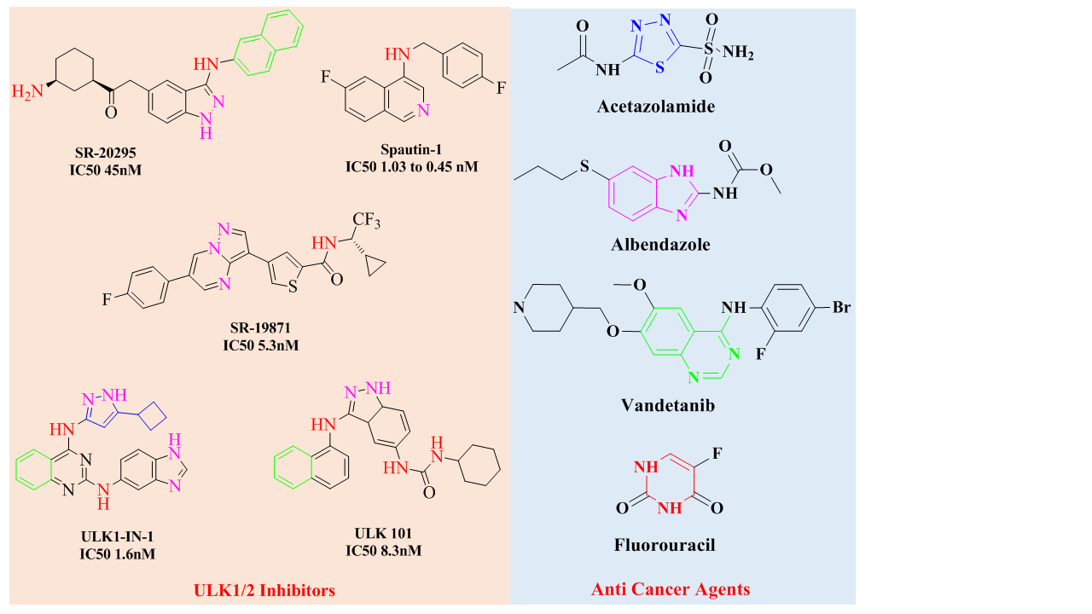

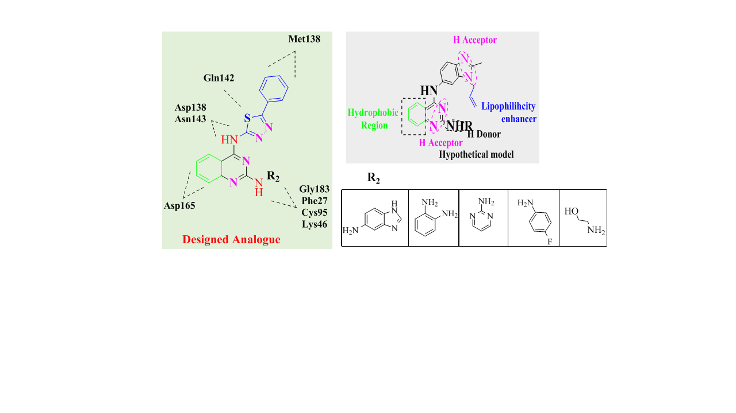

**Fig.1. Designing of molecule**

* 1. ***Chemistry***

The synthesis of quinazoline and aniline derivatives based on thiadiazole is outlined in **schemes 1-3**. The 5-substituted 1,3,4-thiadiazole-2-amines **2a-2f** were synthesized using a simple one-pot reaction of N-aminothiourea with phosphoryl chloride. Cyclization and condensation of 2-amino benzoic acid 3 with urea resulted in Quinazoline-2,4 (1H,3-H)-dione **4.** Refluxing Quinazoline-2,4 (1H,3-H)-dione with TEA produced 2,4-dichloroquinazoline **5**. The substitution reaction of **2a-2f** with 2,4-dichloroquinazoline **5** yielded Quinazoline and Thiadiazole-based derivatives 6a-6f in good yield. Treatment of **6a-6h** with aniline derivatives sequentially produced **7a-7j** through a substitution reaction.



* 1. ***DFT study***

The density functional theory (DFT), a widely used theoretical chemistry method was used for the electronic structure of synthesized compounds. DFT calculation helped to theoretically compute the frontier molecular orbital (FMO) and chemical reactivity descriptors for the synthesized compounds. Calculations were performed to determine the energies of the highest occupied molecular orbital (HOMO) and lowest unoccupied molecular orbital (LUMO) of the synthesized compounds. These values offer insights into the compounds' capabilities to donate or accept electrons. Furthermore, HOMO-LUMO energy gap was calculated because it has important implications to understand the chemical and physical properties of a molecule, including its reactivity, stability, and electronic properties. Moreover, it plays a critical role in determining the ability of a molecule to undergo chemical reactions, particularly those involved in enzymatic reactions and cellular processes. In general, a smaller HOMO-LUMO energy gap specifies the highly reactive compound, as electrons can be excited more easily from the HOMO to the LUMO, leading to increased chemical reactivity. While a higher HOMO-LUMO energy gap denotes a more stable compound that is less likely to undergo chemical reactions. The calculated HOMO-LUMO energy gap of the synthesized compounds indicated that compound 7g showed the highest energy gap compared to others. The order of high to low chemical reactivity of synthesized compounds based on the HOMO-LUMO energy gap is 7g> 7c> 7i> 7h> 7a> 7j> 7d> 7b> 7f> 7e, respectively. DFT study also helped to estimate the ionization potential (IP) and electron affinity (EA). The IP and EA are the energies required to remove or add an electron to a neutral molecule, respectively. Compound The electronegativity (χ) of the synthesized compounds was measured to estimate the ability of an atom to attract electrons in a chemical bond and the parameter can be calculated using the HOMO and LUMO energies and the ionization potential and electron affinity. Similarly, other reactivity descriptors including global hardness (η), chemical potential (μ), and electrophilicity (ω) were studied. The calculated FMO and chemical reactivity descriptors for synthesized compounds are represented in **Fig.2.** and **Table 1.** The DFT study helped to understand the electronic structure and molecular behavior of the synthesized compounds.

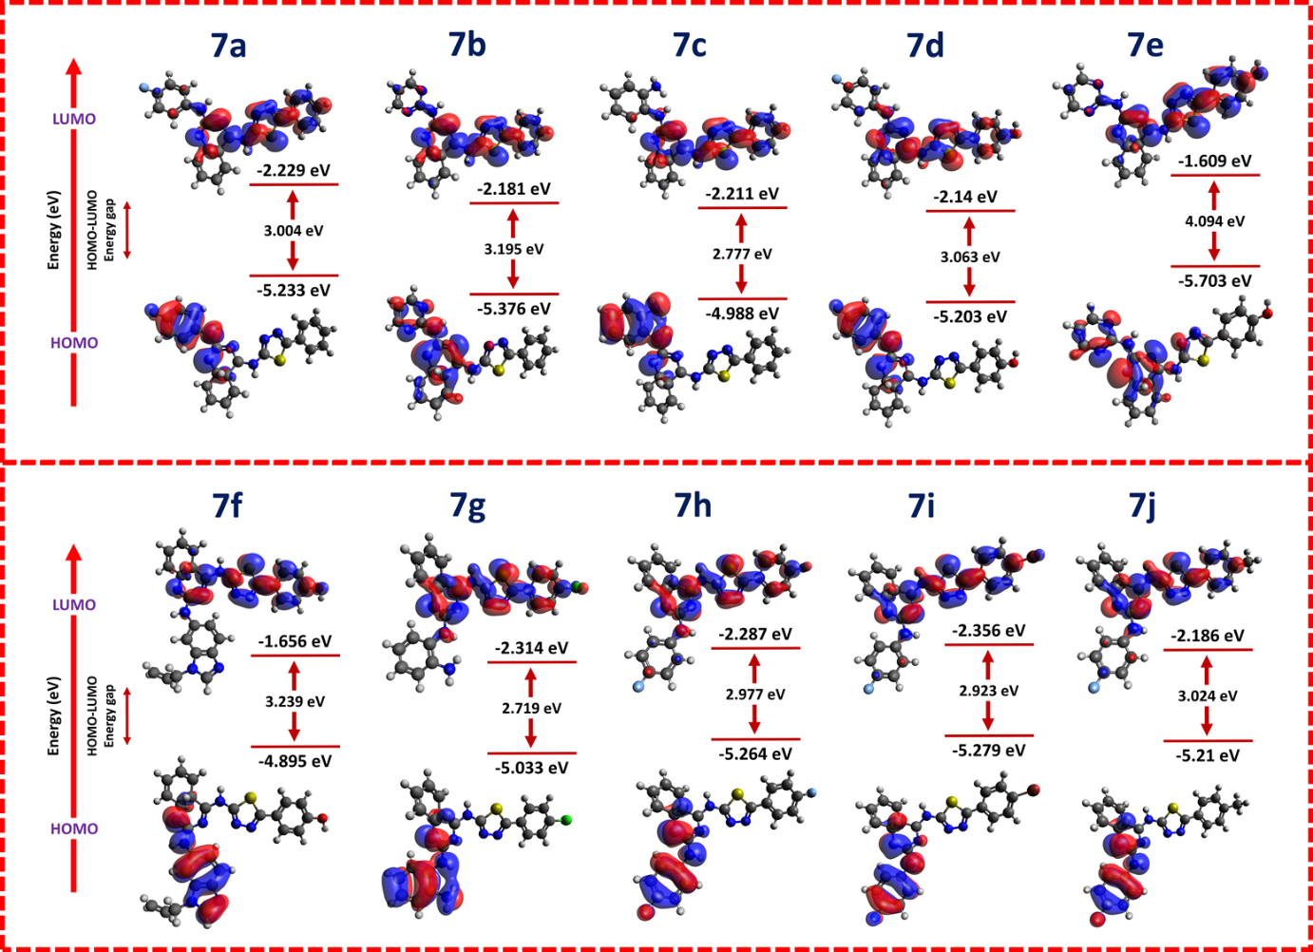

**Fig. 2.** HOMO and LUMO of the compounds having antitubercular activity with good MIC values and HOMO-LUMO energy gap (HLG).

**Table 1.** Calculated frontier molecular orbital energies and reactivity descriptors for synthesized compounds using DFT method.

|  |  |  |  |  |  |  |  |  |  |  |
| --- | --- | --- | --- | --- | --- | --- | --- | --- | --- | --- |
| **Code** | **HOMO (eV)** | **LUMO (eV)** | **HLG (eV)** | **DM (Debye)** | **IP (eV)** | **EA (eV)** | **χ (eV)** | **µ (eV)** | **η (eV)** | **ω (eV)** |
| **7a** | -5.233 | -2.229 | 3.004 | 8.1133 | 5.23 | 2.229 | 3.731 | -3.73 | 1.502 | 4.633 |
| **7b** | -5.376 | -2.181 | 3.195 | 5.0704 | 5.37 | 2.181 | 3.778 | -3.778 | 1.597 | 4.468 |
| **7c** | -4.988 | -2.211 | 2.777 | 6.8332 | 4.98 | 2.211 | 3.599 | -3.599 | 1.388 | 4.665 |
| **7d** | -5.203 | -2.14 | 3.063 | 7.5548 | 5.20 | 2.14 | 3.671 | -3.671 | 1.531 | 4.4 |
| **7e** | -5.703 | -1.609 | 4.094 | 3.3861 | 5.70 | 1.609 | 3.656 | -3.65 | 2.047 | 3.264 |
| **7f** | -4.895 | -1.656 | 3.239 | 3.4951 | 4.89 | 1.656 | 3.275 | -3.275 | 1.619 | 3.312 |
| **7g** | -5.033 | -2.314 | 2.719 | 6.0423 | 5.03 | 2.314 | 3.673 | -3.673 | 1.359 | 4.963 |
| **7h** | -5.264 | -2.287 | 2.977 | 7.2632 | 5.26 | 2.287 | 3.775 | -3.775 | 1.488 | 4.788 |
| **7i** | -5.279 | -2.356 | 2.923 | 7.1298 | 5.27 | 2.356 | 3.817 | -3.817 | 1.461 | 4.985 |
| **7j** | -5.21 | -2.186 | 3.024 | 8.4959 | 5.21 | 2.186 | 3.698 | -3.698 | 1.512 | 4.522 |

* 1. ***Biology***

***2.4.1 Cell lines and Culture***

The A549 cell line, which is derived from human lung cancer and has a wild-type p53 gene, was obtained from the National Centre for Cell Science (NCCS) in Pune, Maharashtra, India. The cells were cultured in F-12K, Eagle's Minimum Essential Medium (EMEM), and RPMI1640 mediums at 37 °C in 5% CO2. To ensure their purity, the cell lines were regularly checked for the presence of Mycoplasma and Epstein-Barr Virus.

***2.4.2 In vitro antiproliferative assay (MTT Assay)***

The antiproliferative effects of the synthesized compound were assessed using the MTT (3-(4,5-dimethylthiazol-2-yl)-2,5-diphenyltetrazolium bromide) assay. The A549 cell line was seeded at a density of 104 cells per well in 96-well plates and allowed to adhere for 24 hours at 37°C with 5% CO2. Triplicate wells with varying concentrations of the test compounds (0.01, 0.1, 1, 10, 100, and 1000 μM) were then treated for 24 hours, with cisplatin serving as a positive control and untreated cells as blanks. After incubation, MTT solution (5 mg/mL) was added to each well and incubated further for 4 hours in the dark at 37°C. The resulting purple-colored formazan crystals were dissolved in DMSO, and the optical density (OD) was recorded at 570 nm using a microplate spectrophotometer. Blanks containing media without cells were included. The IC50, the concentration at which 50% of cell growth was inhibited, was calculated using GraphPad software by comparing the OD reading with the control.

**Table 2.** Structure and *in vitro* antiproliferative activity of synthesized compounds.



|  |  |  |  |
| --- | --- | --- | --- |
| **Compound code** | **R1** | **R2** | **IC50 Value (µM)** |
| **7a** | H |  | 68.02 |
| **7b** | H |  | 208.06 |
| **7c** | H |  | 32.04 |
| **7d** | OH |  | **12.2** |
| **7e** | OH |  | 74.09 |
| **7f** | OH |  | **20.76** |
| **7g** | Cl |  | **16.35** |
| **7h** | F |  | **20.61** |
| **7i** | Br |  | **22.01** |
| **7j** | Methyl |  | 74.88 |

* 1. ***Result***
     1. ***Density functional theory calculation***

The DFT (Density Functional Theory) method was utilized to calculate the global chemical reactivity descriptors as well as the frontier molecular orbitals (FMO) for the synthesized compounds. [28]. Chemical reactivity descriptors including dipole moment (DM), ionization potential (IP), electron affinity (EA), global hardness (η), chemical potential (μ), electronegativity (χ), and electrophilicity (ω) were calculated according to the previously reported equations of Koopmans' theory [29–31]. To perform DFT calculation, B3LYP functional with def2-SVP basis set was done on Orca 4.2.1 software [32, 33]. The orca-enhanced version of Avogadro was utilized to prepare input structures and interpret the output files [34]

* + 1. ***In vitro antiproliferative activities and structure-activity relationships***

To determine their impact on cultured cancer cells, the growth and viability of cancer cells were evaluated using the MTT method after treating them with the synthesized molecules 7a-7j. The antiproliferative activities of the new thiadiazole derivatives were assessed in vitro against A549 (NSCLC), a human cancer cell line. The cytostatic potency, measured as the IC50 value (the concentration that causes 50% inhibition of tumor cell proliferation), was summarized in the **Table 2.** Overall, the synthesized compounds showed moderate to high antitumor activity against the lung cancer A549 cell line in vitro, when compared to the standard antitumor drug Cisplatin. Among the tested compounds, Compound 7d demonstrated potent activity, with IC50 values of 12.2 μM against the A549 cell line. Furthermore, compounds 7g and 7h exhibited significant in vitro antitumor activity, while compounds 7i and 7f showed relatively better antitumor activity. On the other hand, compounds 7a and 7c demonstrated moderate anti-cancer activity, while compounds 7e and 7b displayed weak antiproliferative activity. The chemical moiety present in a molecule primarily determines its electronic, solubility, and steric properties. It is also responsible for the molecule's interaction with specific biological targets, mechanism of action, metabolism, elimination, and duration of action. In this study, the main two regions R1 and R2 were focused on discussing the biological effect. The introduction of electron-donating as well as electron-withdrawing substituents at R1 and R2 position of 7a-7j leads to dramatic increases and decreases in antiproliferative activities. The addition of Cl, F, Br, and OH group at R1 and R2 position give favorable activities. Here, Chlorine atoms are often used in drug design to improve the lipophilicity of a compound, which can enhance its penetration through biological membranes and increase its bioavailability. Chlorine atoms can also increase the metabolic stability of a compound by reducing its susceptibility to enzymatic degradation in the liver. Fluorine atoms are commonly used in drug design to increase the potency and selectivity of a compound. The small size and high electronegativity of fluorine can enhance the binding affinity of a compound to its target receptor by increasing the strength and specificity of intermolecular interactions. Additionally, the addition of fluorine atoms to a drug can improve its pharmacokinetic properties by enhancing its metabolic stability and reducing its clearance rate. Hydroxyl (OH) groups are polar functional groups that can affect the solubility and polarity of a compound. The presence of OH groups can increase the water solubility of a drug and enhance its ability to dissolve in biological fluids, which can improve its pharmacokinetic properties. OH groups can also affect the biological activity of a compound by forming hydrogen bonds with the target receptor and altering its conformation or orientation. However, the presence of OH groups can also increase the susceptibility of a compound to metabolic degradation and reduce its stability. Here, interesting activity was obtained when adding bulkier moieties such as benzimidazole with amine derivatives at the R2 position. It may cause due to the more binding interaction with amino acids on specific target proteins.

1. **Conclusion**

The compounds 7a-7j were synthesized and analyzed using spectral methods. All of the synthesized compounds were found to be druggable by in silico ADME profile and the Pfizer rules. Compound 7d, 7g, 7h, 7f, and 7i demonstrated acute in vitro antiproliferative activity against three human cancer cell lines, with IC50 values of 12.2, 16.35, 20.61, 20.76, and 22.01 µM, respectively, compared to Cisplatin. Additionally, the structure of the compounds was optimized using DFT calculations. The calculated HOMO-LUMO energy gap of the synthesized compounds revealed that compound 7g had the highest energy gap among them.

1. **Experimental Section** 
   1. ***Chemistry: general procedures***

Unless otherwise noted, all commercial starting materials, reagents, and solvents were used without further purification. Reactions were monitored using thin-layer chromatography on 0.25 mm silica gel plates (60GF-254) and visualized with UV light, chloride ferric or iodine vapor. The melting points were measured without correction using an electrothermal melting point apparatus. Infrared spectra were obtained using Shimadzu (FTIR-8400S) series FT-instrument. EI-MS was determined on an Aglient-1100 series LC/MSD trap spectrometer. 1H NMR spectra were obtained using a jewel 400 spectrometer (400 MHz), and the chemical shifts were expressed in parts per million (ppm) relative to tetramethylsilane (TMS) as an internal standard. Significant 1H NMR data were reported in the following order: the number of protons and multiplicity (singlet, s; doublet, d; triplet, t; multiplet, m).

* 1. ***Synthetic procedure***
     1. ***Synthesis of 5-phenyl-1,3,4-thiadiazol-2-amine (2a)***

A mixture of benzoic acid (6.10 g, 50 mmol), N-aminothiourea (4.55 g, 50 mmol), and POCl3 (13 ml) was stirred and heated at 75 C for 0.5 h. Then, the mixture was allowed to cool down to room temperature, and water (55 ml) was added to it. The reaction mixture was further heated under reflux for 4 hours. After cooling, the mixture was made alkaline to pH 8 by the gradual addition of 50% NaOH solution under stirring. The resulting precipitate was filtered and recrystallized from ethanol to obtain 6.5 g of the desired compound 2a in the form of brownish crystals. Yield 85%, mp: 224–226˚C; IR (KBr) Vmax 3281, 3088, 1518, 690 cm-1.

* + 1. ***Synthesis of 4-(5-amino-1,3,4-thiadiazol-2-yl) phenol (2b)***

Compound **2b** was synthesized following the procedure described in Section **(2a)**

Yield 80%, mp: 226˚C; IR (KBr) Vmax 3398, 3245, 3011, 1503, 663 cm-1.

* + 1. ***Synthesis of 5-(4-fluorophenyl)-1,3,4-thiadiazol-2-amine (2c)***

Compound **2c** was synthesized following the procedure described in Section **(2a)**

Yield 75%, mp: 230˚C; IR (KBr) Vmax 3017, 2956, 1669, 1163, 647 cm-1.

* + 1. ***Synthesis of 5-(4-bromophenyl)-1,3,4-thiadiazol-2-amine (2d)***

Compound **2d** was synthesized following the procedure described in Section **(2a)**

Yield 70%, mp: 235˚C; IR (KBr) Vmax 3274, 3087, 1518, 759, 690 cm-1.

* + 1. ***Synthesis of 5-(p-tolyl)-1,3,4-thiadiazol-2-amine (2e)***

Compound **2e** was synthesized following the procedure described in Section **(2a)**

Yield 70%, mp: 222˚C; IR (KBr) Vmax 3309, 3122. 1515, 1463, 654 cm-1.

* + 1. ***Synthesis of 5-(4-chlorophenyl)-1,3,4-thiadiazol-2-amine (2h)***

Compound **2h** was synthesized following the procedure described in Section **(2a)**

Yield 70%, mp: 227˚C; IR (KBr) Vmax 3037, 2806, 1699, 765, 700 cm-1.

* + 1. ***Synthesis of Quinazoline-2,4 (1H,3H)-dione (4)***

A quantity of urea (460 mmol) was heated until it melted, and then 2-methylaminobenzoic acid (46 mmol) was introduced. The mixture was stirred for 5 hours at 150˚C and then cooled to a temperature below 100˚C. To stop the reaction, water (70 mL) was added. The resulting precipitate was collected and purified by recrystallization in a mixed solution of acetone (10 mL) and water (100 mL), leading to the formation of compound 1 as a white powder. (5.25 g, 64.3%); mp 278– 279˚C; IR (KBr) Vmax 3508, 3113, 1676, 1612 cm-1

* + 1. ***Synthesis of 2, 4-dichloroquinazoline (5)***

2,4-dichloroquinazoline was obtained by refluxing 10.0g (0.061 mole) of quinazoline-2,4(1H,3H)-dione(Benzoylene urea) in 14.2g(0.092 mole) of Phosphorous oxychloride with 7.4g(0.061mole)N,N-dimethylaniline at 108°C . The progress of the reaction was monitored by TLC (Eluent: ethyl acetate: hexane=7:3). After the completion, the reaction mass was cooled to room temperature and hence poured onto ice water under stirring. An off-white viscous precipitate formed. The resultant mass was basified with Aqueous 20% w/v of Potassium carbonate to ph 8.0. After reaching the mentioned pH, the reaction mass was extracted with 200.0 ml Dichloromethane. The dichloromethane layer was given a water wash, dried over sodium sulphate, and hence distilled to obtain 5.0 g 2, 4- dichloroquinazoline. Melting point: 118-120°C; IR (KBr) Vmax 3142, 1588, 15212, 873, 752 cm-1

* + 1. ***Synthesis of N-(2-chloro-4a,8a-dihydroquinazolin-4-yl)-5-phenyl-1,3,4-thiadiazol-2-amine (6a)***

DIPEA (0.951ml, 5.3 mmol) was added to a suspension of 2,4 dichloo quinazoline (370 mg, 1.85 mmol) and 5-Phenyl-1,3,4-thiadiazol-2-amino (250mg,0.75mmol) in ethanol (10 ml). The Suspension was stirred at 25 C for 12 hrs. The resulting precipitate was filtered and washed with ethanol to afford 7a-7h (401.5mg, 75% yield) as a white solid. IR (KBr) Vmax 3431, 2924, 1548, 763, 686 cm-1; **m/z:** 341[M+H]+ and 343[M+2H]+

* + 1. ***Synthesis of 4-(5-((2-chloroquinazolin-4-yl)amino)-1,3,4-thiadiazol-2-yl)phenol (6b)***

Compound **6b** was synthesized following the procedure described in Section **(6a)**

Yield 60%, mp:230˚C; IR (KBr) Vmax 3649, 3280, 3091, 1518, 690, 760, cm-1; **m/z:** 355 [M+H]+ and 357[M+2H]+

* + 1. ***Synthesis of N-(2-chloroquinazolin-4-yl)-5-(4-fluorophenyl)-1,3,4-thiadiazol-2-amine (6c)***

Compound **6c** was synthesized following the procedure described in Section **(6a)**

Yield 65%, mp:245˚C; IR (KBr) Vmax 3401, 2930, 1520, 817, 814, 642, cm-1; **m/z:** 357 [M+H]+ and 359[M+2H]+

* + 1. ***Synthesis of 5-(4-bromophenyl)-N-(2-chloroquinazolin-4-yl)-1,3,4-thiadiazol-2-amine (6d)***

Compound **6d** was synthesized following the procedure described in Section **(6a)**

Yield 70%, mp: 248˚C; IR (KBr) Vmax 3352, 3029, 1514, 693, 830, 786, cm-1; **m/z:** 416 [M+H]+ and 418[M+2H]+

* + 1. ***Synthesis of N-(2-chloroquinazolin-4-yl)-5-(p-tolyl)-1,3,4-thiadiazol-2-amine (6e)***

Compound **6e** was synthesized following the procedure described in Section **(6a)**

Yield 60%, mp: 238˚C; IR (KBr) Vmax 3360, 3063, 1533, 836, 676, cm-1; **m/z:** 352 [M+H]+ and 354 [M+2H]+

* + 1. ***Synthesis of 5-(4-chlorophenyl)-N-(2-chloroquinazolin-4-yl)-1,3,4-thiadiazol-2-amine (6f)***

Compound **6h** was synthesized following the procedure described in Section **(6a)**

Yield 62%, mp: 245˚C; IR (KBr) Vmax 3319, 3149, 1570, 660, 769, 837, cm-1; **m/z:** 376 [M+H]+ and 378 [M+2H]+

* + 1. ***Synthesis of N2-(4-fluorophenyl)-N4-(5-phenyl-1,3,4-thiadiazol-2-yl)-4a,8a-dihydroquinazoline-2,4-diamine (7a)***

A mixture of 6a-h (24.3mg, 0.081mmol), and aniline derivatives (55.4mg, 0.416mmol) in ethanol (1.5 ml) was stirred at 120˚ C in a sealed vial for 1 h. and the reaction mixture was cooled and purified with a suitable solvent. Yield 55%, mp:249˚C; IR (KBr) Vmax 3487, 3182, 1583, 763, 638, cm-1; **1H NMR (DMSO-d6) δ ppm;** 6.90-6.99 (m, 4H, Quinazoline Ar-H), 7.04-7.83 (m, 4H, 4-Floroaniline Ar-H), 8.14-8.16 (m, 4H, Thiadiazole Ar-H), 11.05 (s, 1H, NH), 12.23 (s, 1H, NH); **m/z:** 418 [M+2H]+

* + 1. ***Synthesis of N4-(5-phenyl-1,3,4-thiadiazol-2-yl)-N2-(pyrimidin-2-yl)quinazoline-2,4-diamine (7b)***

Compound **7b** was synthesized following the procedure described in Section **(7a)**

Yield 52%, mp: 243˚C; IR (KBr) Vmax 3487, 3043, 1533, 638, cm-1; **1H NMR (DMSO-d6) δ ppm;** 4.49-5.26 (m, 4H, Quinazoline Ar-H), 6.90-7.98 (m, 4H, Pyrimidine, Ar-H), 8.01-8.02 (m, 4H, Thiadiazole Ar-H), 10.93 (s, 1H, NH), 11.06 (s, 1H, NH); **m/z:** 400 [M+H]+

* + 1. ***Synthesis of N2-(2-aminophenyl)-N4-(5-phenyl-1,3,4-thiadiazol-2-yl)quinazoline-2,4-diamine (7c)***

Compound **7c** was synthesized following the procedure described in Section **(7a)**

Yield 50%, mp: 247˚C; IR (KBr) Vmax 3452, 3030, 2839, 1531, 696, cm-1; **1H NMR (DMSO-d6) δ ppm;** 5.11-6.53 (m, 4H, Quinazoline Ar-H), 6.90 (d, 2H, NH2), 7.30-7.98 (m, 2H, Orthophenylene diamine, Ar-H), 8.00-8.02 (m, 4H, Thiadiazole Ar-H), 11.76 (s, 1H, NH), 11.78 (s, 1H, NH); **m/z:** 413 [M]+

* + 1. ***Synthesis of 4-(5-((2-((4-fluorophenyl)amino)quinazolin-4-yl)amino)-1,3,4-thiadiazol-2-yl)phenol (7d)***

Compound **7d** was synthesized following the procedure described in Section **(7a)**

Yield 52%, mp: 241˚C; IR (KBr) Vmax 3456, 3290, 3146, 1506, 754, 700 cm-1; **1H NMR (DMSO-d6) δ ppm;** 5.45-5.59 (d, 2H, Quinazoline Ar-H), 6.61-6.67 (d, 2H, Quinazoline Ar-H), 7.91-7.60 (m, 4H, 4-Floroaniline Ar-H), 7.61-8..26 (m, 4H, Thiadiazole Ar-H), 10.90 (s, 1H, NH), 11.45 (s, 1H, NH), 12.0 (s, 1H, OH); **m/z:** 433 [M+H]+

* + 1. ***Synthesis of 4-(5-((2-(pyrimidin-2-ylamino)-4a,8a-dihydroquinazolin-4-yl)amino)-1,3,4-thiadiazol-2-yl)phenol (7e)***

Compound **7e** was synthesized following the procedure described in Section **(7a)**

Yield 52%, mp: 241˚C; IR (KBr) Vmax  3462, 3355, 3081, 1612, 678, cm-1; **1H NMR (DMSO-d6) δ ppm;** 6.90-6.21 (m, 4H, Quinazoline Ar-H), 7.64-7.60 (m, 4H, Pyrimidine Ar-H), 7.93-7.66 (m, 4H, Thiadiazole Ar-H), 11.00 (s, 1H, NH), 11.39 (s, 1H, NH), 12.39 (s, 1H, OH); **m/z:** 418 [M+2H]+

* + 1. ***Synthesis of 4-(5-((2-((1-allyl-1H-benzo[d]imidazol-6-yl)amino)-4a,8a-dihydroquinazolin-4-yl)amino)-1,3,4-thiadiazol-2-yl)phenol (7f)***

Compound **7b-IV** was synthesized following the procedure described in Section **(7aI)**

Yield 50%, mp: 245˚C; IR (KBr) Vmax 3368, 3281, 1525, 1157, 645, cm-1; **1H NMR (DMSO-d6) δ ppm;** 3.43-3.93 (3, 3H, CH=CH, H), 4.10-4.92 (m, 2H, methyl), 5.11-5.24 (m, 4H, Quinazoline Ar-H), 5.99-7.61(m, 3H, Benzimidazole Ar-H), 7.62-7.89 (m, 4H, Thiadiazole Ar-H), 11.11 (s, 1H, NH), 11.25 (s, 1H, NH), 12.50 (s, 1H, OH); **m/z:** 494 [M+H]+

* + 1. ***Synthesis of N2-(2-aminophenyl)-N4-(5-(4-chlorophenyl)-1,3,4-thiadiazol-2-yl)quinazoline-2,4-diamine (7g)***

Compound **7g** was synthesized following the procedure described in Section **(7a)**

Yield 55%, mp: 245˚C; IR (KBr) Vmax 3290, 3032, 2879, 1531, 877, 694, cm-1; **1H NMR (DMSO-d6) δ ppm;** 6.19 (d, 2H, NH2), 6.87-7.32 (m, 4H, Quinazoline Ar-H), 7.34-7.72 (m, 4H, 4-Orthophenylene, Ar-H), 7.78-8.11 (m, 4H, Thiadiazole Ar-H), 11.19 (s, 1H, NH), 11.40 (s, 1H, NH); **m/z:** 447 [M+H]+  **and m/z:** 449 [M+2H]+

* + 1. ***Synthesis of N2-(4-fluorophenyl)-N4-(5-(4-fluorophenyl)-1,3,4-thiadiazol-2-yl)quinazoline-2,4-diamine (7h)***

Compound **7h** was synthesized following the procedure described in Section **(7a)**

Yield 50%, mp: 240˚C; IR (KBr) Vmax 3433, 3290, 1583, 742, 678, cm-1; **1H NMR (DMSO-d6) δ ppm;** 4.523-4.54 (d, 2H, Quinazoline Ar-H), 5.00-5.25 (m, 2H, Quinazoline Ar-H), 7.11-7.23 (d, 4H, 4-Floroaniline Ar-H), 8.13-8.68 (m, 4H, Thiadiazole Ar-H), 11.42 (s, 1H, NH), 11.66 (s, 1H, NH); **m/z:** 433 [M-1H]+

* + 1. ***Synthesis of N4-(5-(4-bromophenyl)-1,3,4-thiadiazol-2-yl)-N2-(4-fluorophenyl)quinazoline-2,4-diamine (7i)***

Compound **7i** was synthesized following the procedure described in Section **(7a)**

Yield 51%, mp: 246˚C; IR (KBr) Vmax 3437, 3184, 1537, 833, 750, 636, cm-1; **1H NMR (DMSO-d6) δ ppm;** 7.25-7.27 (m, 4H, Quinazoline Ar-H), 7.28-7.35 (m, 4H, 4-Floroaniline Ar-H), 7.36-8.17 (m, 4H, Thiadiazole Ar-H), 11.11 (s, 1H, NH), 11.51 (s, 1H, NH); **m/z:** 493 [M+H]+ and495 [M+2H]+

* + 1. ***Synthesis of N2-(4-fluorophenyl)-N4-(5-(p-tolyl)-1,3,4-thiadiazol-2-yl)quinazoline-2,4-diamine (7j)***

Compound **7j** was synthesized following the procedure described in Section **(7a)**

Yield 55%, mp: 243˚C; IR (KBr) Vmax 3402, 2987, 1591, 1419, 765, 680, cm-1; **1H NMR (DMSO-d6) δ ppm;** 3.34 (m, 3H, methyl) 6.64-6.70 (m, 4H, Quinazoline Ar-H), 6.91-7.44 (m, 4H, 4-Floroaniline Ar-H), 7.57-7.84 (m, 4H, Thiadiazole Ar-H), 11.36 (s, 1H, NH), 11.47 (s, 1H, NH); **m/z:** 430 [M+H]+

**References**

1. Sung H, Ferlay J, Siegel RL, et al (2021) Global Cancer Statistics 2020: GLOBOCAN Estimates of Incidence and Mortality Worldwide for 36 Cancers in 185 Countries. CA Cancer J Clin 71:209–249. https://doi.org/10.3322/CAAC.21660

2. Bray F, Jemal A, Grey N, et al (2012) Global cancer transitions according to the Human Development Index (2008–2030): a population-based study. Lancet Oncol 13:790–801. https://doi.org/10.1016/S1470-2045(12)70211-5

3. Kocarnik JM, Compton K, Dean FE, et al (2022) Cancer Incidence, Mortality, Years of Life Lost, Years Lived With Disability, and Disability-Adjusted Life Years for 29 Cancer Groups From 2010 to 2019: A Systematic Analysis for the Global Burden of Disease Study 2019. JAMA Oncol 8:420–444. https://doi.org/10.1001/JAMAONCOL.2021.6987

4. Nagai H, Kim YH (2017) Cancer prevention from the perspective of global cancer burden patterns. J Thorac Dis 9:448–451. https://doi.org/10.21037/JTD.2017.02.75

5. Cancer. https://www.who.int/news-room/fact-sheets/detail/cancer. Accessed 4 Aug 2022

6. Xia C, Dong X, Li H, et al (2022) Cancer statistics in China and United States, 2022: profiles, trends, and determinants. Chin Med J (Engl) 135:. https://doi.org/10.1097/CM9.0000000000002108

7. Denton D, Kumar S (2018) Autophagy-dependent cell death. Cell Death & Differentiation 26:605–616. https://doi.org/10.1038/s41418-018-0252-y

8. Saha S, Panigrahi DP, Patil S, Bhutia SK (2018) Autophagy in health and disease: A comprehensive review. Biomedicine and Pharmacotherapy 104:485–495

9. Galluzzi L, Maiuri MC, Vitale I, et al (2007) Cell death modalities: classification and pathophysiological implications. Cell Death Differ 14:1237–1243. https://doi.org/10.1038/sj.cdd.4402148

10. Strasser A, O’Connor L, Dixit VM (2003) Apoptosis Signaling. Annu Rev Biochem 69:217–245. https://doi.org/10.1146/ANNUREV.BIOCHEM.69.1.217

11. Fairlie WD, Tran S, Lee EF (2020) Crosstalk between apoptosis and autophagy signaling pathways. In: International Review of Cell and Molecular Biology. Elsevier Inc., pp 115–158

12. Jung S, Jeong H, Yu SW (2020) Autophagy as a decisive process for cell death. Experimental & Molecular Medicine 52:921–930. https://doi.org/10.1038/s12276-020-0455-4

13. Green DR, Llambi F (2015) Cell Death Signaling. Cold Spring Harb Perspect Biol 7:. https://doi.org/10.1101/cshperspect.a006080

14. Su M, Mei Y, Sinha S (2013) Role of the crosstalk between autophagy and apoptosis in cancer. J Oncol. https://doi.org/10.1155/2013/102735

15. Arfin S, Jha NK, Jha SK, et al (2021) Oxidative Stress in Cancer Cell Metabolism. Antioxidants 10:642. https://doi.org/10.3390/ANTIOX10050642

16. Hayes JD, Dinkova-Kostova AT, Tew KD (2020) Oxidative Stress in Cancer. Cancer Cell 38:167–197. https://doi.org/10.1016/J.CCELL.2020.06.001

17. Pandey A, Yadav P, Shukla S (2021) Unfolding the role of autophagy in the cancer metabolism. Biochem Biophys Rep 28:101158. https://doi.org/10.1016/J.BBREP.2021.101158

18. Kondo Y, Kanzawa T, Sawaya R, Kondo S (2005) The role of autophagy in cancer development and response to therapy. Nat Rev Cancer 5:726–734. https://doi.org/10.1038/nrc1692

19. Linder B, Kögel D (2019) Autophagy in Cancer Cell Death. Biology (Basel) 8:82. https://doi.org/10.3390/BIOLOGY8040082

20. Shimizu S, Yoshida T, Tsujioka M, Arakawa S (2014) Autophagic Cell Death and Cancer. Int J Mol Sci 15:3145–3153. https://doi.org/10.3390/IJMS15023145

21. Limpert AS, Lambert LJ, Bakas NA, et al (2018) Autophagy in Cancer: Regulation by Small Molecules. Trends Pharmacol Sci 39:1021–1032

22. Limpert AS, Lambert LJ, Bakas NA, et al (2018) Autophagy in Cancer: Regulation by Small Molecules. Trends Pharmacol Sci 39:1021–1032. https://doi.org/10.1016/J.TIPS.2018.10.004

23. Chan EY, Tooze SA (2009) Evolution of Atg1 function and regulation. Autophagy 5:758–765

24. Lee EJ, Tournier C (2011) The requirement of uncoordinated 51-like kinase 1 (ULK1) and ULK2 in the regulation of autophagy. Autophagy 7:689–695. https://doi.org/10.4161/auto.7.7.15450

25. Ro SH, Jung CH, Hahn WS, et al (2013) Distinct functions of Ulk1 and Ulk2 in the regulation of lipid metabolism in adipocytes. Autophagy 9:2103–2114. https://doi.org/10.4161/AUTO.26563/SUPPL_FILE/KAUP_A_10926563_SM0001.ZIP

26. Demeter A, Romero-Mulero MC, Csabai L, et al (2020) ULK1 and ULK2 are less redundant than previously thought: computational analysis uncovers distinct regulation and functions of these autophagy induction proteins. Sci Rep 10:1–17. https://doi.org/10.1038/s41598-020-67780-2

27. Petherick KJ, Conway OJL, Mpamhanga C, et al (2015) Pharmacological Inhibition of ULK1 Kinase Blocks Mammalian Target of Rapamycin (mTOR)-dependent Autophagy. J Biol Chem 290:11376–11383. https://doi.org/10.1074/jbc.C114.627778

28. Miar M, Shiroudi A, Pourshamsian K, et al (2021) Theoretical investigations on the HOMO–LUMO gap and global reactivity descriptor studies, natural bond orbital, and nucleus-independent chemical shifts analyses of 3-phenylbenzo[d]thiazole-2(3H)-imine and its para-substituted derivatives: Solvent and substituent effects. J Chem Res 45:147–158

29. Patial PK, Cannoo DS (2021) Phytochemical profile, antioxidant potential and DFT study of Araucaria columnaris (G. Forst.) Hook. Branch extracts. Nat Prod Res 35:4611–4615. https://doi.org/10.1080/14786419.2019.1696330

30. Puthanveedu V, Muraleedharan K (2022) Phytochemicals as potential inhibitors for COVID-19 revealed by molecular docking, molecular dynamic simulation and DFT studies. Struct Chem 33:1423–1443. https://doi.org/10.1007/s11224-022-01982-4

31. Elkaeed EB, Yousef RG, Elkady H, et al (2022) Design, Synthesis, Docking, DFT, MD Simulation Studies of a New Nicotinamide-Based Derivative: In Vitro Anticancer and VEGFR-2 Inhibitory Effects. Molecules 27:. https://doi.org/10.3390/molecules27144606

32. Neese F (2012) The ORCA program system. Wiley Interdiscip Rev Comput Mol Sci 2:73–78. https://doi.org/10.1002/wcms.81

33. Kausar T, Nayeem SM (2018) Identification of small molecule inhibitors of ALK2: a virtual screening, density functional theory, and molecular dynamics simulations study. J Mol Model 24:. https://doi.org/10.1007/s00894-018-3789-2

34. Snyder HD, Kucukkal TG (2021) Computational Chemistry Activities with Avogadro and ORCA. J Chem Educ 98:1335–1341. https://doi.org/10.1021/acs.jchemed.0c00959